# Pre-Reqesitue 2.Software

|  |  |
| --- | --- |
| Date | 09 NOVEMBER 2022 |
| Roll no | 73771913143 |
| Project name | Project-Real Time River Water Quality Monitoring  And Control System |
| Maximum Marks | 2 Marks |

## Software:

Software is a set of instructions, data or programs used to operate computers and execute specific tasks. It is the opposite of hardware, which describes the physical aspects of a computer. Software is a generic term used to refer to applications, scripts and programs that run on a device.

## Software:

**Python 3.7 and Python 3.7.0 shell has been created**

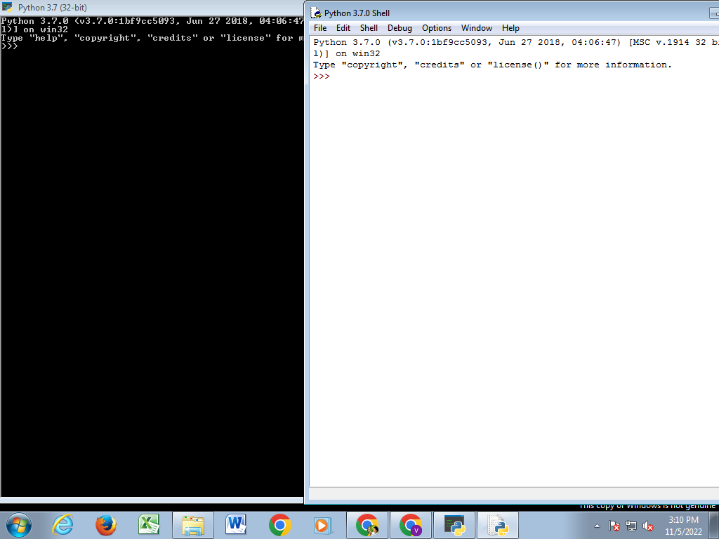

# Arduino IDE with ada fruit and pubsubclient libraries

